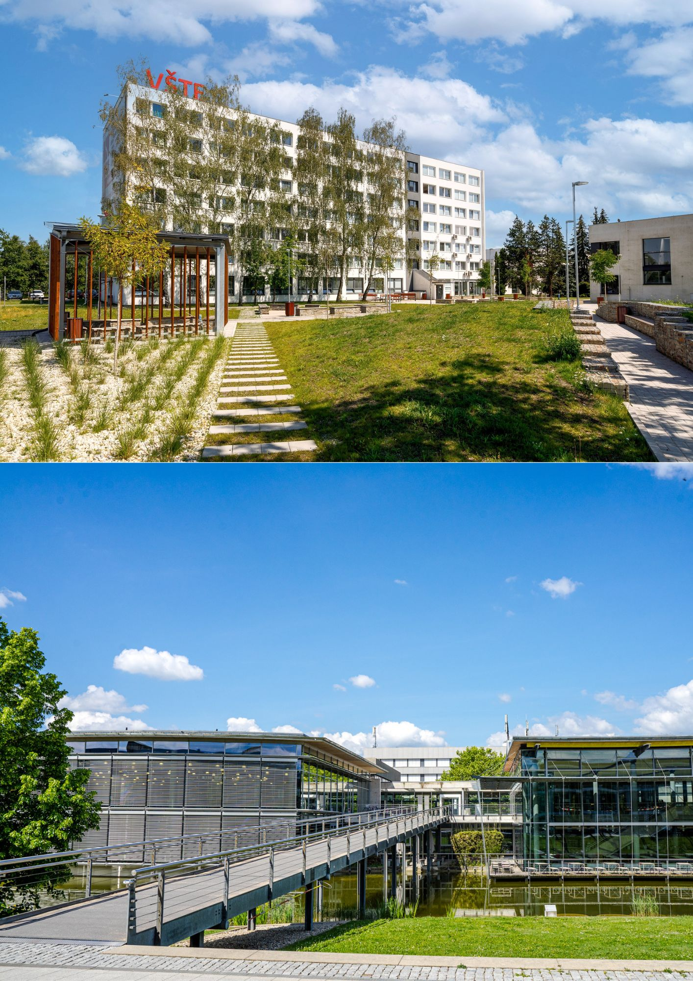

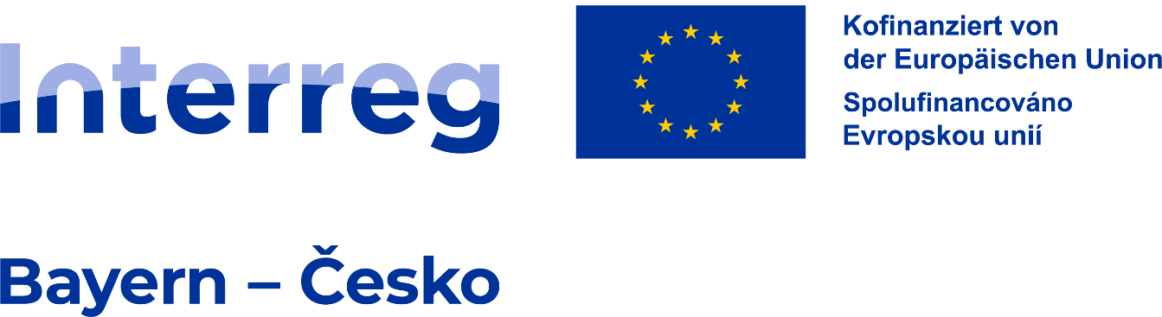

Business plan
OSTBAYERISCHE TECHNISCHE HOCHSCHULE REGENSBURG
VYSOKÁ ŠKOLA TECHNICKÁ A EKONOMICKÁ V ČESKÝCH BUDĚJOVICÍCH

2025

Business Plan Template
Name student: xxx
Student number: xxx
Course code: xxx Module number: xxx
Lecturer: xxx
Credits: x
Language: xxx
Semester: Winter 2025
Instructions for Writing the Business Plan
This template has been designed as a joint standard for students from VŠTE České Budějovice and OTH Regensburg. The aim is to provide a unified structure for the Business Plan and ensure compatibility across both institutions.

Requirement | Specification
Format | A4. Margins – left 3.5 cm; right 2.5 cm; top and bottom 2.5 cm.
Font | Times New Roman, 12 pt
Line spacing | 1.5
Paragraph | First line indent 0.5 cm; alignment justified
Headings | Chapter titles – bold, 14 pt; Subheadings – bold, 12 pt
Tables/Figures | Numbered and labelled (Tables: title above, Figures: title below)
Citations | ISO 690 (Author, Year)
References | List at the end of the document
Length | 15–20 standard pages (1 page = 1800 characters incl. spaces)

Table of Contents
1 Executive Summary 5
2 Business Description 6
3 Description of the product or service 7
4 Business Model Canvas 8
5 Market Assessment 9
5.1 Industry analysis 9
6 Competitive Situation and Contribution to the Bavaria–South Bohemia Region 10
7 Marketing and Sales 11
7.1 Marketing mix 11
8 Operations & Management 12
9 Financial Plan 13
10 Critical Risks 14
11 Future Development and Milestones 15
12 Formal Aspects 16
13 Source 17
Literature 18
Appendix 19

Executive Summary
In this chapter, you should:
- Summarize your business idea in the cross-border region.
- Why is the Bavaria–South Bohemia region an ideal place to start?
- Summarize the main opportunities and risks.
- Provide only a brief summary, maximum 1 page.

Business Description
In this chapter, you should:
- What is your business idea (product, service, innovation)?
- Who is your target audience? Who will be your customers?
- What are the unique benefits of your offering? / What makes your business unique?
- What problems are you solving for customers?
- What goals have you set for your company, and how do you intend to achieve them? (Quality goals, service goals, growth goals)
- How do you plan to grow?
- What are the basic financial objectives (sales, market share, and profitability, etc)
- What inspired you to choose this field of business? Focus on the unique features of the product and comparisons with competitors.

Description of the product or service
In this chapter, you should:
- Describe the product or service in detail:
  - Useful features,
  - Ability to satisfy customer needs,
  - Design,
  - Packaging,
  - Warranty and post-warranty service, etc.
- What innovative features does your product or service offer? Compare with existing competitors.
- What will be most interesting for your customers about the product or service (price, design, useful features, etc.)? List three items and explain.

Business Model Canvas
In this chapter, you should:
- map out your business idea using the Business Model Canvas framework. Canvas provides a structured overview of how your company creates, delivers, and captures value. It serves as a bridge between your product/service description and the detailed market, competition, and financial analyses.
- Fill in the business model Canvas in Appendix 2.

Market Assessment
In this chapter, you should:
- Describe your industry/market using statistics, studies, and trends.
- Define your target group in detail (age, income, business/private, consumer behavior).
- What developments/trends do you expect?
- How do you respond to customer needs?

Industry analysis
- How big is the sector in which you will operate? Focus only on companies that produce the same product or service and target the same customer segments.
- What are the general trends in this sector? Is it growing, staying the same, or slowing down?
- Do you see any important changes in this sector?
- How might these changes affect your business?
- Are you aware of any changes that could seriously affect your business in the medium or long term?
  - Political changes,
  - Legislative changes,
  - Social changes,
  - Environmental changes,
  - Technological changes,
  - Other changes.
- How attractive is the sector to new market entrants? What are the barriers to entry? How profitable are companies in the sector?

Competitive Situation and Contribution to the Bavaria–South Bohemia Region
In this chapter, you should:
- Who are your direct and indirect competitors?
- What is the market size in the cross-border region?
- Where are their weaknesses from a customer perspective?
- What are your company’s strengths compared to competitors?
- What are competitors’ pricing strategies and distribution channels?
- How will your business contribute to the economic development of the region?
- How will you support employment and investments in the region?
- How will you strengthen cross-border cooperation?
- How will you address regional challenges (demographics, innovation, environment)?
- What social and cultural contributions can your business bring?

Marketing and Sales
In this chapter, you should:
- Which strategy will you choose (price orientation or service orientation)?
- Which marketing activities will you pursue, and what are the estimated costs?
- Which marketing channels will you use (website, social media, advertising, newsletters)?
- Through which channels will you sell your product/service (online shop, retail, direct sales)?
- Which regional target areas are you aiming for?

Marketing mix
- You can use at least 4P, but also 7P, 4C, or others.

Product or service (what we want to sell)
- Just a brief recap of the main attributes for marketing purposes, taken from Chapter 3.

Price (what pricing strategy we choose)

Place (where we want to sell)

Promotion (what marketing communication tools you will use and how)

Operations & Management
In this chapter, you should:
- What personal qualities and experiences will you bring to the business? Focus on education, knowledge, and moral character.
- What legal form will your company take?
- Are any permits required?
- Who will manage the business, and how will responsibilities be divided?
- How will tasks be allocated (marketing, sales, finance, purchasing, etc.)?
- How will production/service delivery be organized?
- What is your personnel plan (number, type of employees, skills, functions, salaries)?

Financial Plan
In this chapter, you should:
- What is your capital requirement?
- What investments are necessary?
- Provide a sales and profitability plan, including cash flow.
- Provide liquidity plan for 12-24 months (Appendix No. 1)
- Explain where your start-up funding is coming from – as bank loans, equity (selling a part of your business), or from risk investors (business angels or venture capitalists) – as well as how you are going to use those funds, and when you will be able to pay them back (if a payback is required)
- How will you communicate with investors, and what added value can they provide?

Critical Risks
In this chapter, you should:
- Identify the business risk, the probability of its occurrence, the degree of impact, and measures to eliminate it. Fill in the table.
Risk description | Probability of risk occurrence (range from 0 to 1) | Risk impact level (range from 0 to 1) | Risk significance (product of columns a and b) | Risk elimination actions
a | b | c | d | e
Note:
- Risk description: a short, clear definition of the business risk.
- Probability of risk occurrence (range from 0 to 1): the probability that a negative situation will occur.
- Risk impact (range from 0 to 1): how the risk will affect the business. A value of "1" means the end of the business.
- Risk significance: (product of columns a and b)
- Risk elimination measures: only address risks with a significance of 0.2 or higher.

Future Development and Milestones
In this chapter, you should:
- What are your long-term goals?
- What growth strategies do you plan?
- What expansion opportunities do you see?
- Fill in the table (add the necessary number of rows to the table). Include all points leading to the fulfilment of this business plan.
Milestone/proof of completion | Date of completion | Costs in EUR

Formal Aspects
In this chapter, you should:
- What legal framework applies to your business?
- In which country will you establish your company?
- In which markets will you operate? (Germany/Czech/Both)
- How will you protect intellectual property?
- What formal requirements of the business plan must be fulfilled?

Source
In-text citations
- Cite using the author’s surname and year of publication in parentheses.
  - Example: (Barringer, 2015)
- For a specific page: (Baker & Nelson, 2005, p. 329-366)
- For multiple authors:
  - Two authors: (Baker & Nelson, 2005)
  - Three or more authors: (Smallbone et al., 2012)

Literature
Baker, T. & Nelson, R. E. (2005). Creating something from nothing: resource construction through entrepreneurial bricolage. Administrative Science Quarterly, 50(3), 329 – 366, DOI: https://doi.org/10.2189/asqu.2005.50.3.329.
Barringer, B. R. (2015). Preparing Efficient Business Plans: an Entrepreneurial Approach (2nd Edition). Essex, England: Pearson Education. ISBN: 978-1-292 05933-4.
Bloßfeldt, S. (2024). Becoming (hyper-) aware of cross-border interdependencies – tracing public representations of Czech commuters on the Bavarian border, Journal of Borderlands Studies, pp. https://doi.org/10.1080/08865655.2024.2330078. 1 – 20, DOI:
Smallbone, D., Welter, F. & Xheneti, M. (2012). Cross-Border Entrepreneurship and Economic Development in Europe´s Border Regions. Edward Elgar. ISBN: 978 1-84844-768-4.

Appendix
In this chapter, you should:
- Include supporting materials – statistics, graphs, surveys, and financial calculations.
Appendix No. 1
Figure 1: Appendix No. 1
 | Initial cash balance | January | February | March | April | May | June | July | August | September | October | November | December | Final cash balance
Bank account
(income – expenditure)
Income (+)
Expenditure (-) | X
Cash (income – expenditure) | X
Income (+) | X
Expenditure (-) | X
Total (bank account + cash)

 |  | Designed for (name of product): |  |  | Designed by (student names): |  | Date: |  | Version:
Appendix No. 2  Business Model Canvas |  |  |  |  |  |  |  |  | 2025
Key Partners | Key Activities | Value Propositions (=products) |  |  | Customer Relationships |  | Customer Segments
Who are our Key Partners? Who do we need help from to run our successful business? Who are our key suppliers? | What Key Activities do our business require? What are the things we need to be good at to deliver our value propositions (=valuable products)? | Which products will we offer to each Customer Segment? How does our product solve a customer’s problems? Which customer needs are we satisfying? |  |  | What type of relationship does each of our Customer Segments expect from us to establish and improve loyalty with them? |  | For whom are we creating value? Who are our most important customers? Is our customer base a mass market or segmented for specific target groups?
 | Key Resources |  |  |  | Channels
 | What key resources are needed to deliver our value propositions? |  |  |  | Through which Channels do our Customer Segments want to be reached? Which ones will work best? Which ones will be most cost-efficient?
Cost Structure |  |  | Revenue Streams
What are the most important costs associated with our business model? Which Key Resources are most expensive? Which Key Activities are most expensive? |  |  | How do we capture value (money) from our customers? For what value are our customers really willing to pay?

